OFFICIAL COORDINATION REQUEST FOR
NON-ROUTINE OPERATIONS AND MAINTENANCE

COORDINATION TITLE- 20JDA05 MOC Spill bay 10 repair
COORDINATION DATE- 5/11/20
PROJECT- John Day
RESPONSE DATE- 5/25/20

Description of the problem

Spill bay 10 at John Day Dam is being operated manually by Operations since a problem with its gearbox was found in late April. The spill bay was out of service from 10 April -20 April and not responding to commands from the control room to raise or lower. Electricians were able to restore operation of the spill gate locally. Operations staff have been raising and lowering the gate locally as the spill pattern changes for flex spill and flow changes.

John Day project needs to restore remote control operation of the spill gate back to the control room and avoid an operator having to manually operate the gate as flows change.

Type of outage required
Spill bay 10 will be out of service for one week starting on 16 June, the first day after Spring spill season, to fix the gearbox and restore the remote control function. The gate would be on seal and cannot be dogged at a specific set point.

Impact on facility operation (FPP deviations)
The outage would affect spill patterns and flow would need to be dispersed elsewhere to stay within the 35% spill operation for summer fish passage operations.

Impact on unit priority- no impact

Impact on forebay/tailwater operation- no impact

Impact on spill
The spill pattern will be out of criteria but the volume will be correct. Spill gate 10 is located in the middle of the spillway and its discharge is lower compared to other gates in the spill pattern. The flow will be diverted to other gates to stay in criteria.

Dates of impacts/repairs 16 June – 23 June

Length of time for repairs 1 week

Analysis of potential impacts to fish
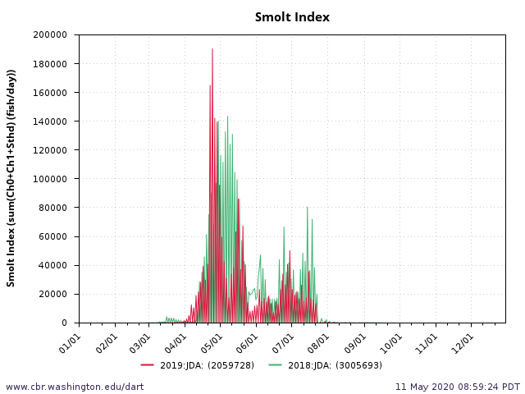
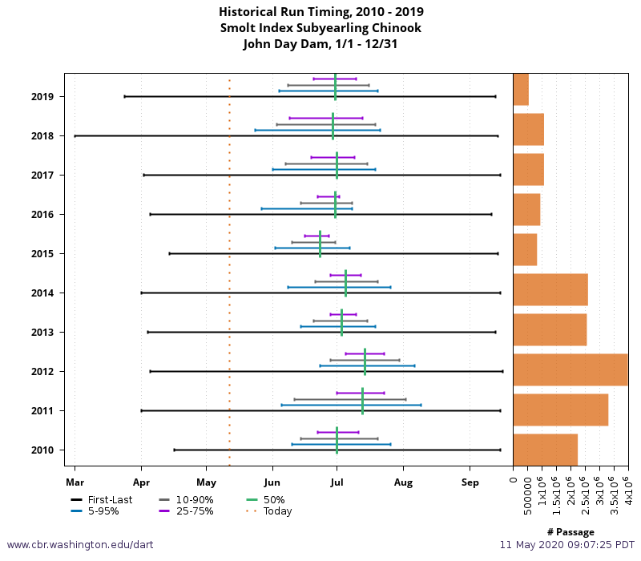

Summary statement - expected impacts on:

Downstream migrants - Minimal impact to downstream migrants is anticipated by this action. The vast majority of yearling Chinook, Steelhead, Coho and Sockeye salmon have passed John Day dam by 16 June. Sub-yearling Chinook salmon will be most affected by having the spill bay out of service. The date proposed for this action was picked based on historic run timing. The lull period typically seen between CH1 and CH0 was picked to help minimize the impact to downstream migrants, specifically CH0.

Upstream migrants (including Bull Trout) – This action is not expected to impact upstream migrants.

Lamprey- This action is not expected to impact lamprey.

Comments from agencies

Final coordination results

After Action update (After action statement stating what the effect of the action was on listed species. This statement could simply state that the MOC analysis was correct and the action went as expected, or it could explain how the actual action changed the expected effect (e.g., you didn’t need to close that AWS valve after all, so there was no impact of the action). List any actual mortality noted as a result of the action)

Please email or call with questions or concerns.
Thank you,
Erin

Erin Kovalchuk
NWP Operations Division Fishery Section
Columbia River Coordination Biologist
Erin.H.Kovalchuk@usace.army.mil

